The use of Interactive Domain Specific Languages for Generative Rule-based systems

Mark Rudolph, PhD.
Rovsing Aerospace, Copenhagen, Denmark.
e-mail: mark_rudolph@yahoo.com

Abstract
Domain Specific Languages (DSLs) allow descriptive expressions of generative
code for the production of 3D scenegraph objects. In particular, DSL syntax allows the interactive creation of ‘axioms’ for a generative rule-based system, and for interactive development of any node or branch in the scenegraph tree at any point in the process of form development. The action of the DSL is an interactive guidance and intervention which helps shape the convergence of process to a desired form and style when developing in a generative rule-based system. The Ruby language supports a particularly elegant implementation methodology for a DSL representing 3D tree structures, and for rule-based actions which are triggered by pattern matches on structure and semantics of specific nodes. The 3D tree can be created dynamically by DSL using idioms of Ruby such as meta-programming, message interception, and the passing of dynamically chosen actions using closures. Specific 3D developmental method implementations can be attached dynamically to nodes which are invoked simply by interactively asserting the names of the nodes in the simple syntax of the DSL. Particular forms can be placed at positions in the scenegraph by assertions in the DSL and further assertions may invoke actions on the tree. At the same time Rule objects may traverse the tree in a 'Visitor' design pattern, or dually, Transform3D facts can traverse rule subsets, modifying nodes and the tree structure by pattern matching against properties of nodes and their associated transform and semantic values, and applying actions when a match is found.

1. Introduction
The motivation for using generative systems for production of 3D objects is the difficulty and tediousness of modelling by use of tools and hand construction. The need for skilled labour on each piece using expensive tools drives up the cost of production and slows completion times. The situation resembles that of a Medieval guild in which expensive skilled artists labour extensively at one piece at a time. Biology inspired practices, rule-based programming, and interactive DSL-based command syntax, offer a promising solution, allowing both automated and interactive production methodology based on 'growing' instances instead of building them. The methodology is efficient and automated, and the expression of stylistic preferences in rule sets permits decision making by an inference system instead of by the use of complex and tedious modelling toolsets. In addition, DSLs can be used to interactively guide the tendency of form creation at any point in the process. Sentences in the DSL represent branches in the scenegraph tree but at the same time are executing snippets of Ruby program code. At any time in the interactive session entire scripts of Ruby code can be run as well. In this manner automated rule actions and interactive assembly and shaping can be used in complementary sessions during the overall process of form development.

The basic terminology is borrowed from genetics and corresponds essentially to biological meaning. The fact tree consisting of hierarchical 3D transform information is referred to as the ‘genotype’ which in biology refers to the inheritable information carried by all living organisms [1.] In the specialized meaning in 3D graphics the genotype is an abstract 3D structure with either no associated form or perhaps merely a simple bounding box at each leaf in the fact tree. The ‘populated genotype’ is a genotype in which all components contain a non-trivial String form in a text syntax which can be rendered and made visible in 3D space. Production rules act on an initial genotype ‘axiom’ and through iterative operation produce a more and more complex genotype. The real or potential form associated with each leaf is referred to as a ‘component.’

The ‘phenotype’ of an organism represents its actual physical properties, such as height, weight, color, shape and so on. In the context of 3D scenegraphs the phenotype is an isomorphic mapping of the genotype populated with a 3D form at each leaf expressed in a specialized syntax which can be both rendered visibly and programmed. Phenotypes are created by a different category of rules called population rules. A clear distinction between genotype and phenotype is that genotypes carry only structural information whereas phenotypes carry both structural information and phenomenal information about rendered forms. The structural element of the description can be thought of as the objectified process of moving a component in 3D by a sequence of hierarchical 3D operations. The form of a component refers to its shape, material, geometry, surface, and animation and behavioral properties.

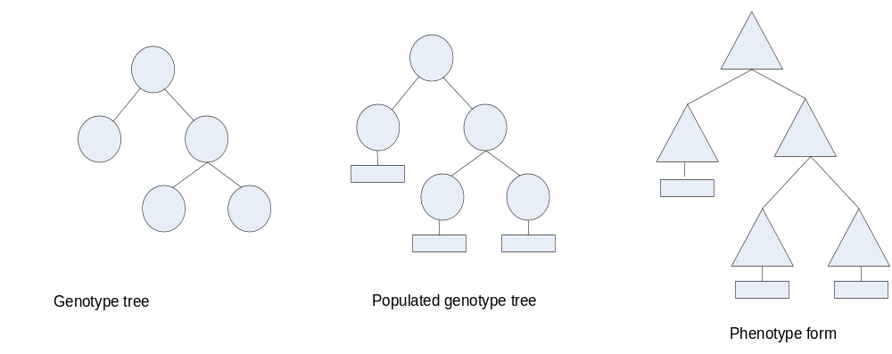
Figure 1: isomorphic trees

Each node in the scenegraph tree also has a name and can be referred to by name.
A DSL is a specialized language which has linguistic meaning but is also executable program code. The use of a DSL enables the speaking of names in the scenegraph as a way to initially create a node of that name, and define a method on that node of the same which is then executed in subsequent speaking of that name. Ruby is an ideal language to implement DSLs and the interactive version of Ruby called ‘irb’ is an ideal environment in which to run the development process. Ruby is an interpreted language so there is no compilation of source code to executable code. The source code is also the executable code which runs in the Ruby interpreter ‘ruby.’ The irb interactive Ruby interpreter is the same interpreter but runs line by line in an interactive session. The process of creating scenegraph structures is to describe their structure in the language of the DSL which is run in the interpreter to gradually create the tree described step by step in the sentences of the DSL which are written at the command line. The typing of sentences of the DSL speak and represent the structure of a branching tree. However, the sentence is also executable Ruby code which runs after enter is pressed to start irb. A simple example is the following:

root=Tree.new

This utterance creates a unique ‘root’ node in the scenegraph tree.

root.branch1{p “branch1 method” }

This speaking adds a child node named ‘branch1’ to root and defines a method on root having name ‘branch1.’

root.branch1

This second speaking of the names executes the method branch1 on root which in this case is ‘p “branch1 method”’ which simply prints out “branch1 method.” Any node in the tree can be the leftmost word in the sentence. This generality permits interactive development of any node or branch in the tree.

These sentences in the DSL are run one by one in the irb interactive shell. However,
at any point in the process an entire Ruby program can also be run by entering
‘require <program_name>’ in the command line of irb. In this manner interactive and automated sessions can be interleaved. The DSL and its interpretation in Ruby is an ideal medium in which to apply both automated and interactive sessions of generative form creation. The following discussion will concentrate on the particular syntax and techniques in Ruby enabling the use of an interactive DSL and automated applications of rules. The methodology of use is to alternate between interactive DSL sessions and automated development of the scenegraph tree by rule sets. The goal is to guide the rule-based development of form to converge to a final form which has desired characteristics and style.

2. Generative Rule-based systems
A rule-based system is a software system for reasoning about and transforming a dynamic fact base according to sets of rules. In generative systems rule sets capture stylistic preferences for iteratively defining and elaborating 3D objects as they develop in space.

Rule sets are ‘swarms’ of tendencies operating on a potential form and in ways that social insects might construct a hive. There is no central control program but complex and intricate structures are produced by sequences of small transforms. ´
A rule-based inference system consists of a dynamic set of facts called ‘working memory,’ sets of rules called a ‘rule base,’ and an inference engine consisting of a pattern matcher, an agenda which holds the set of rules activated by matches on the present cycle, and an execution engine which fires one rule per cycle. A rule consists of a left hand side (LHS) ‘antecedent’ which is the specification of some state of fact(s), and a right hand side (RHS) ‘consequent’ which consists of actions such as method invocations, modifications assertions or retractions of facts, introductions of new rules, or modification of the set of rules able to fire in the next cycle.

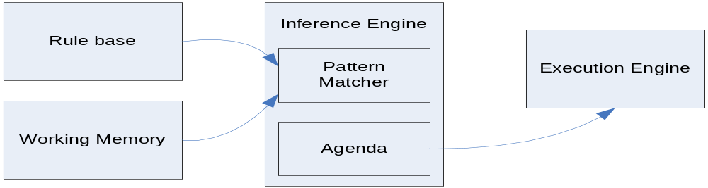

Figure 2: Rule-based system

A generative rule-based system is one in which the rules act to create and modify facts corresponding to some type of structural form such as the scenegraph of a renderable 3D object. The form could also be music, text or images. Fractals and L-systems are types of generative systems.

In the Ruby system (detailed discussion to follow) rules and facts are classes and the inference engine is eliminated since facts are transform nodes in a scenegraph tree, and rules simply traverse nodes or branches of transforms. Rules carry their own means to pattern match and execute actions upon discovery of a node which generates a match. In the application discussed here, the generation of 3D objects, the facts are graphical transforms and 3D components, and the rules perform pattern matching on transform properties, semantic propositions, and meta-information such as depth of the node in the tree, iteration number, number of nodes of a certain component from, etc.

In the generative 3D system the facts are all Transform3D objects which contain attributes of name, parent, children, depth in the tree, relative translation, rotation and scale, and absolute location, orientation and dimensions, and a set of propositions (possibly empty) which characterizes the node and/or relations between the node and other nodes. The parent is the unique node for which the node is a child, and the children are the nodes contained in the particular node. The set of all Transform3D facts is a tree which describes the hierarchical arrangement of transform operations which operate on the a node at the root and move it out to its location, rotate it to its orientation, and scale it to its spatial dimensions.

Rules may act on facts, or vice-versa, since each extends the Node class which contains methods permitting one node to traverse the tree and perform pattern matching and actions, and also for accepting node visitors traversing the tree. The Visitor design pattern is used in which the visitor A calls the method ‘accept’ on a tree node B with itself(A) as argument, and the implementation of accept calls the method ‘visit’ on A with itself(B) as argument. This technique is termed double dispatch. In all cases the effect is that the rule checks if the fact has a state which matches some Boolean expression of properties, and if so the rule fires some set of actions such as creating new nodes or modifying the properties of the visited node.

Rules may be applied to facts interactively in the DSL syntax, or by programmatic iteration through nodes or branches of the scenegraph tree. When rules modify the transform properties of a particular fact A the modification must be applied to A and transmitted down the nodes of all branches beginning at A. Each node modifies its absolute transform coordinates by the modification made at A. This is achieved by the node A calling the method traverse on itself and sending itself as argument which results in A visiting itself and the entire sub-tree of A.
At each node the absolute coordinates are updated by the relative transform applied to A.

3. Semantics for Facts
Geometric aspects of the Transform3D fact provide a wealth of properties with which to match the LHS of the rules. However there is no way to determine ‘qualities’ or ‘functions’ of the component form at that node by geometric properties alone. By including a Semantics module in Transform3D the geometric properties are augmented with the ability of the Transform3D fact to contain propositions representing descriptive characteristics of its form and appearance, its function in the overall structure, its qualities as simple ‘tags,’ or its relationships to other objects. This vastly increases the decision-making capability of rules.

Instead of knowing simply the position, orientation and dimensions of an object, descriptive functionality can be encoded such as (:corner, wall1, wall2) which states the relation of :corner exists between objects wall1 and wall2. Then rules can match against (:corner,*,*) and will fire actions on all objects which are at a corner. The rule could then extract the names of the corner pair object satisfying the proposition, say :wall1 (the visited node) and :wall2 . The action might be to add a proposition (:base_of_roof, wall1, wall2) to wall1, and add a key-value pair <:base_of_roof, [[:wall1,:wall2]]> to a Hash which is accessible to all Rules.
The rule has added a key :base_of_roof with value an array of pairs consisting of the two names of the nodes which form a corner. Similar pattern matching on (:corner,*,*) at other nodes may cause additional pairs to be added. Another subset of rules might pattern mach on the :base_of_roof value in the Hash waiting for the number of pairs to equal four which would then stimulate the construction of nodes as a roof. This use of semantic ‘phermones’ models the behaviour of social insects. Termites build huge complicated mounds by simple rules and a simple system of social communication. Initially groups of termites begin to (perhaps) randomly deposit particles of moist particles. Their behaviour is to deposit the particles at points which are accumulating the most particles. Groups of towers begin to rise with all but the tallest few abandoned. Then one or more termite may sense a particular height has been attained and leave a pheromone message to cause the group to begin to angle the columns toward each other until arches are created. At that point another message is left to fill in the walls.

Simple propositions such as (:quality, :self, :self) act as tags which characterize the properties of the Transform3D node. Rules can then pattern match for the presence of a quality and act accordingly. In addition, the action of a rule may modify the set of propositions, and thus mark some location in the structure and some behavioural role as ‘completed.’
The DSL can select branches in the tree for which a proposition holds:

branch1.children_satisfy?(:relation).each{|node| p "inference method”; node }.etc…

This sentence selects all child nodes of branch1 which satisfy the proposition :relation
and takes action on those nodes.

Rules can also use the DSL in applying actions. Since all DSL methods are added to Object, the superclass of all classes, Rule can execute DSL sentences in the context of all added methods to Object. Therefore the actions of a rule (RHS) may include DSL syntax since the base context for all DSL messages is Object. Thus the action ‘branch1.leaf1’ may be in the set of actions of the Rule, since Rule has the method ‘branch1’ already defined on Object, and so on Rule.

3. Use of the DSL syntax

Add three methods to all objects (Ruby idioms)

class Object

#singleton
def add_singleton_method(sym,proc)
class << self
self
end.instance_eval{define_method(sym,proc)}
end

#instance
def add_instance_method(sym,proc)
self.class.class_eval{define_method(sym,proc)}
end

#class
def add_class_method(sym,proc)
class << self.class
self.class
end.instance_eval{define_method(sym,proc)}
end
end

This module ‘method_additions’ supplies all objects with the ability to add singleton method it single objects, instance methods to objects, and class methods to the classes of those objects. It is interesting to note the symmetry of the singleton method addition on objects with the class method addition on classes – a class is an instance of class Class so the singleton method additions to the Class object are class methods on the specific Class.
Next we add methods to Object to permit starting of the DSL syntax at any point in the tree since the methods required are by the following defined in every object because they are define in class Object. The method tree returns the created Transform3D node.

#global 'main' reference
$zen=self

class Object

attr_reader :children

def add_child(key,object)
@children ||={}
@children[key]=object
end

def has_child?(name)
return @children.member?(name) ? true : false
end

def tree(&block)
if block_given? ? Object.add_instance_method(:root,lambda(&block)) :
Object.add_instance_method(:root,lambda {@children[:root]})
Transform3D.new(:root,$zen,{})
end
end

#--------------------------------------------------------------------------------------------------
root=tree{p "method root"}

Recall:
$zen=self
class Object
#...
def tree(&block)
block_given? ? Object.add_instance_method(:root,lambda(&block)) :
Object.add_instance_method(:root,lambda {@children[:root]})
Transform3D.new(:root,$zen,{})
end
end

This code creates root node and adds it as child of the underlying Main Object identified by the global reference '$zen' At the same time an instance_method is added to Object with the name :root and implementation given in the optional block. If no block is passed in the default behavior is to return a reference to the newly created node so that further DSL syntax has a Transform3D reference to support additional methods ‘spoken’ in the DSL syntax.

The reason for this operation is so that we can then type 'root' and execute the method :root on the global reference to the ‘Main’ Object $zen (example rotate the entire scenegraph)
Now a method ‘branch1’ is invoked on ‘root.’

root.branch1{p "method branch1"}

However Transform3D :root has no method branch1. As in the technique first developed in Groovy Builders, and used to create Ruby Builders: method_missing is used to do something useful. Because ‘branch1’ is not defined on ‘root,’ method_missing is called with symbol :branch1 and the block supplied. The result is to define a method on Object :branch1 which has the implementation given in the block. Finally it returns a reference to the Transform3D ,child of both Object and Transform3D.

root.branch1{p "method branch1"}
#...

def method_missing(key,&block)

if self.has_child?(key) then
self.send(key,&block)
else
object=Transform3D.new(key,self,{})
self.add_child(key,object)
$zen.add_child(key,object)
block_given? ? $zen.add_instance_method(key,lambda(&block)) :
$zen.add_instance_method(key,lambda{@children[key]})
end

#NOTE:self is ‘parent’
@children[key]
end

The method ‘method_missing’ is called to create a Transform3D object and defines a method
‘branch1’ on Object which thus defines the method on all objects including Transform3D

In addition, Transform3D includes the module Seed which defines parameterized Proc factory methods such as the following:

def helix_y(angle,translation,spiral)
lambda do |n| n.times{
spiral<<tr=Transform3D.new(angle.to_s+translation.to_s,self,{})
spiral.each{|node| node.r[1]+=angle;node.t[1]+=translation}
spiral[n-1]
end
end
public :helix

This Proc factory method creates a helical development of sixteen nodes from :branch1 in the y-direction at an angular increment of 0.1 radians and translation increment of 2 units, , and returns the Proc defined within helix, which when ‘called’ with the number of nodes in the development. The Proc returns a reference to the last Transform3D created so that the DSL sentence can continue, and thus finally adds a leaf node to the last node of the helical development:

root.branch1
root.branch1.helix_y(0.1,2,[]).call(16).leaf1{p "method leaf1";yield if block_given?; @children[:leaf1]}.form=filename

The fully defined method at :branch1 includes the following terse but powerful code:

root.branch1 do |*proc|
yield if block_given? #execute block-Proc
proc.nil? ? (puts "method branch1") : proc.each{|p| p.call(@children[:branch1])}
return @children[:branch1]
en vd
branch1.leaf1{p "method leaf1";yield if block_given?;@children[:leaf1]}.form=filename

branch1.method_missing adds a :branch2 node to the tree and adds a method :branch2 to node :branch1

The created method :branch2 does something, executes a block if given, and returns the node :branch2=branch1.children[:branch2]

Finally branch1.method_missing returns the :branch2 node and adds to it a 3D form contained in the file ‘filename

Assume there is a multi-branched tree-axiom i.e. many branches such as root.branch1.branch<2..n>{}

Assume also a set of propositions has been added to these nodes

branch1.children_satisfy?(:relation).each{|node| p "inference method”; node }.etc…

Rule Visitors to the scenegraph tree
Rule matches properties of Facts –> action(s)

Fact respond_to?:

def traverse(visitor)
#calls node.accept(visitor) for all nodes in the subtree
end

def accept(visitor)
return self if visitor.nil?
if visitor.respond_to(:visit,false) then
visitor.visit(self) #double dispatch
end
end

So a typical usage:
Rule Visitors to the scenegraph tree
Rule matches properties of Facts –> action(s)

Fact respond_to?:

def traverse(visitor)
#calls node.accept(visitor) for all nodes in the subtree
end

def accept(visitor)
return self if visitor.nil?
if visitor.respond_to(:visit,false) then
visitor.visit(self) #double dispatch
end
end

So a typical usage:
branch<k>.children.each{|b| b.traverse(rule_visitor); b}.etc..

s branch<k>.children.each{|b| b.traverse(rule_visitor); b}.etc..

